1. **Additional Fields to Capture: Order Drop Time**
2. Include order drop time in [Order Maintenance] Screen

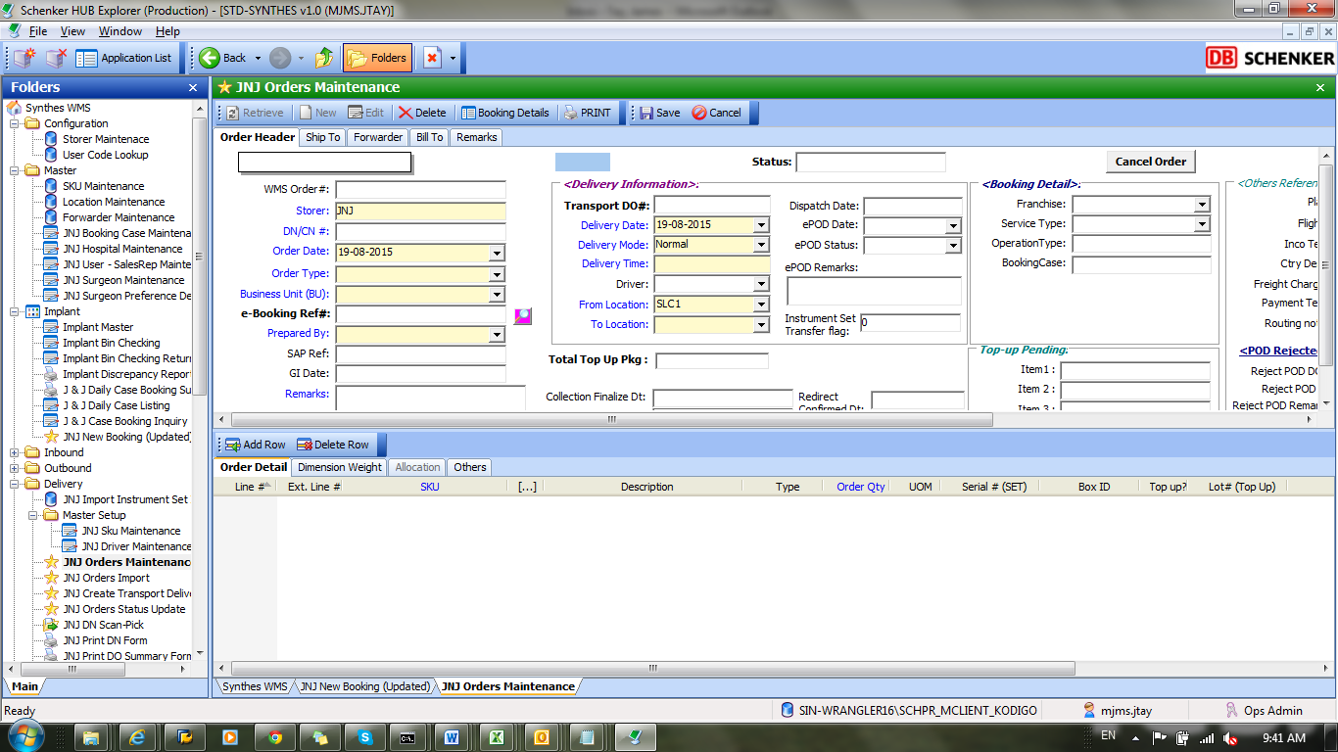

Include Order Drop time:

* Additional field in “HHMM” format, for ops to manually key in order drop time

1. Include order drop time field as Pop Up box in Orders Import

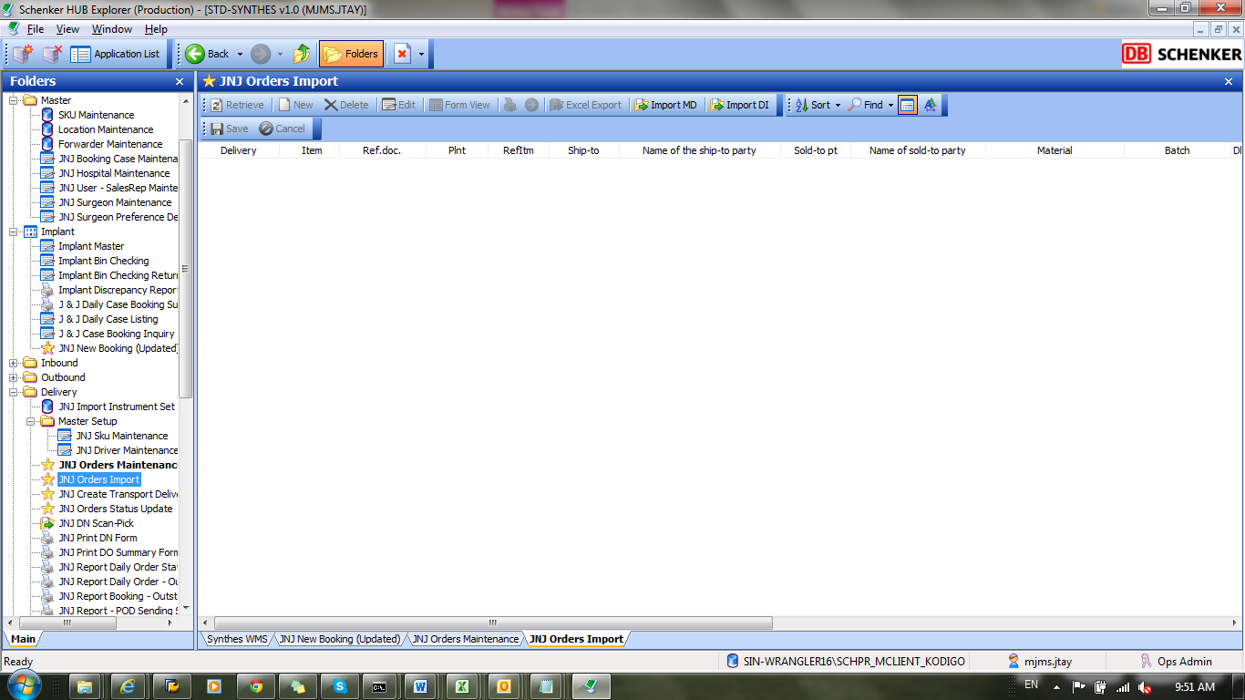

Pop Up Box/Additional Field

* To allow ops to input [order drop time] for uploaded orders for uploaded orders

1. **Additional Fields for Capture: Requestor Name**

Include Requestor Name here:

* For bookings, can populate requestor from “requestor” field in JNJ booking screen
* For other order, select requestor from drop down list